**INDUSTRIAL TRAINING REPORT**

**ON**

**IOT BASED E-VOTING MACHINE**

*A report submitted in partial fulfilment of the requirement for the award of*

*The degree of*

**BACHELOR OF TECHNOLOGY**

**In**

**COMPUTER SCIENCE AND ENGINEERING**



**Submitted By:-**

Name Rishabh garg

ROLL NO. : 160102133

Batch : 2016-2020

**Department of Information Technology**

**DIT UNIVERSITY, DEHRADUN**

(State Private University through State Legislature Act No. 10 of 2013 of Uttarakhand and approved by UGC)

**Mussoorie Diversion Road, Dehradun, Uttarakhand - 248009, India.**

**2019**

**DECLARATION**

I here by certify that the work, which is being presented in the report/ project report, entitled **IOT Based E-Voting Machine**, in partial fulfilment of the requirement for the award of the Degree of **Bachelor of Technology** and submitted to the institution is an authentic record of my own work carried out during the period ***from 27.05.2019***to ***to 27.06.2019***under the supervision of **Mr. Vikas.**

**Date: Signature of the Candidate**

**Signature of Internal faculty Supervisor**

**ACKNOWLEDGEMENT**

This report has been prepared for the internship that has been done in the Sphinx Worldbiz Ltd.

The aim of this internship is to be familiar to the practical aspect and uses of theoretical knowledge and clarifying the career goals, so I have successfully completed the internship and compiled this report as the summary and the conclusion that have drawn from the internship experience. I would like to express my sincere gratitude to our internship coordinator who have given their valuable time and given me chance to learn something despite having their busy schedule and Mr. Vikas his great guidelines for internship.

 Thus, the time in Sphinx Worldbiz Ltd was very audacious and supportive to my career through which I have gained valuable work experience that will help definitely makes a favourable impression on me as a prospective future employer.

**Name Rishabh garg**

**Roll no 160102133**

**ABSTRACT**

Electronic voting system is an important tool which allows voters to vote over the Internet without the geographical restrictions with considers important criteria in evaluating electronic voting schemes such as the mobility, democracy, and privacy. There are a number of voting systems adopted all over the world with each of them having its peculiar problems. The main task of this project is to introduce the idea of the internet voting systems and it describes the design of a voting machine counter through the internet.

After receiving the instruction from the polling officer, the user can use the button to poll his/her vote. In the screen the name and the votes of the candidate is displayed. Apart from this one can cast his/her vote online also by logging in the account using the information which will be provided by government through message.

Once this system is get implemented we need not to worry about our voting as one of the main purpose of this system is a person can vote from any place in India to his/her native region in India. This will reduce time consuming factors, various travelling issues, fake voting, and displaying of result will be easy and fast.

**TABLE OF CONTENT**

CHAPTER PAGE

Chapter 1 -- Organization Overview 1

1.1. Introduction 1

1.2. Services provided by company 1

Chapter 2 –Introduction to Project 3

Chapter 3 – Modules of the Project 10

Chapter 4- Implementation Details 14

Chapter 5 – Screen Shots 18

Chapter 6 – Conclusion 21

Chapter 7 – Future scope 22

Bibliography 23

Abbreviations 24

**LIST OF FIGURES**

FIGURE NAME PAGE

1. Diagram of proposed system 5
2. Use case diagram for admin 15
3. Use case diagram for Voter 16
4. Use case diagram for Election authority 17

**CHAPTER 1 ORGANIZATION OVERVIEW**

**1.1 Introduction**

Incorporated in the year 1996, as a small company with a big vision, Sphinx Worldbiz’s IT division has witnessed unprecedented growth. Preferred as a reputed IT solution & services provider worldwide, the division maintains a track record of delivering excellent and cost effective IT solutions. The unit has achieved total financial stability and is growing solely based on internally generated funds.

Their methodology consists of the following:

* Software Development Lifecycle
* Managed Competency Centers
* Quality Assurance
* Data security and IPR

Known for flawless project development and deployment record over the years, the company performs as technology partners with many software product companies globally and is ISO 9001: 20008 & ISO 27001:2005 along with Dun and Bradstreet certified for its processes. The division is manned by a dedicated team of qualified software professionals. Our exposure to markets across US, the Caribbean, Europe & India has leveraged the competencies of our team to meet every critical and unique IT solution demanded by our global clientele.

**1.2 Services provided by company**

Sphinx Worldbiz is an India-based IT Solutions & Services provider which offers customized applications, mobility, e-Commerce portals, ERP solutions, software migration, systems integration and a host of other IT service requirements across verticals to its global clientele.

With its indigenous enterprise products such as HRMS, CRM, we bring core expertise in developing turnkey projects to cater to clients from a range of industries including Real Estate, Travel & Tourism, Sports, Automobile, Banking & Finance, Petroleum & Energy, and Government Institutions and Educational set-ups across USA, the Caribbean, Europe & India markets.

Along with this they also provide popular services like Big Data, Artificial Intelligence, Blockchain, Testing Services and video technology.

**CHAPTER 2 INTRODUCTION TO PROJECT**

Elections are a defining feature of democratic government, but all too frequently, we take the actual mechanics of the election for granted. We speak at length of such issues as who is allowed to vote, how campaigns are conducted, and how they are financed, but no one gives priority to the understanding of the actual voting process[3].

**Existing System**

1. **Paper-based voting**: The voter gets a blank ballot and use a pen or a marker to indicate he want to vote for which candidate. Hand-counted ballots is a time and labor consuming process, but it is easy to manufacture paper ballots and the ballots can be retained for verifying, this type is still the most common way to vote.
2. **Vote through Postal Ballot**: In sporadic and special cases, people can vote by post. This process is known as Postal Ballot. People who are living overseas or due to certain reasons can go for this option. In many cases, army people are given this privilege and people living overseas. However, this is not yet a system in India or for Indians living overseas.
3. **EVMs**: Electronic Voting is the standard means of conducting elections using [Electronic Voting Machines](https://en.wikipedia.org/wiki/Electronic_Voting_Machines" \o "Electronic Voting Machines), sometimes called "EVMs" in [India](https://en.wikipedia.org/wiki/India" \o "India). The use of EVMs and electronic voting was developed and tested by the state-owned Electronics Corporation of India and Bharat Electronics in the 1990s. They were introduced in Indian elections between 1998 and 2001, in a phased manner. The electronic voting machines have been used in all general and state assembly elections of India since 2004.

**Problems with the Existing Voter Registration System**

The problems of the existing manual system of voting include among others the following:

1. Expensive and Time consuming: The process of collecting data and entering this data into the database takes too much time and is expensive to conduct, for example, time and money is spent in printing data capture forms, in preparing registration stations together with human resources, and there after advertising the days set for registration process including sensitizing voters on the need for registration, as well as time spent on entering this data to the database.
2. Too much paper work: The process involves too much paper work and paper storage which is difficult as papers become bulky with the population size.
3. Errors during data entry: Errors are part of all human beings; it is very unlikely for humans to be 100 percent efficient in data entry.
4. Loss of registration forms: Some times, registration forms get lost after being filled in with voters’ details, in most cases these are difficult to follow-up and therefore many remain unregistered even though they are voting age nationals and interested in exercising their right to vote.
5. Short time provided to view the voter register: This is a very big problem since not all people have free time during the given short period of time to check and update the voter register.

**Proposed System**

Nowadays in India, at the time of voting peoples face many problems, like they need to travel to their native place, they need to spend money for travelling, due to this various health related problems they face and finally mental stress due to all this. Also in case of Government, they need to keep all the ballots safe before voting and counting of votes from different machines, adding them together, keeping data secrete and displaying of result[4]. All these things are very costly, lengthy, time consuming, health and mental affecting. To minimize or to clear all these problems we made a new system, that is “IOT BASED E-VOTING”. Now how we will overcome these problems? The answer is we need to build or design a system where people need not to do travel very long distance only for voting purpose, they need not to spend money from their pocket and very important thing is all the process should be hassle free[4]. This system will work on internet so it will be very helpful and useful for all of us in coming future.

**Internet of things (IOT)**

The internet of things (IOT) is the inter-networking of physical devices, vehicles, building and other items embedded with electronics, software, sensors, actuators and network connectivity which enables these objects to collect and exchange data[2]. The IOT allows objects to sense or controlled remotely across existing network infrastructure, creating opportunities for more direct integration of the physical world into computer-based system, and resulting in improve efficiency, accuracy and economic benefit in addition to reduce human intervention[2]. In the broadest sense, the IOT encompasses everything connected to the internet, but it is increasingly being use to define objects that "talk" to each other. Simply, the Internet of things is made up of device - from simple sensors to smart phones and wearable's - connected together.

LCD Screen

ESP 8266

Arduino Uno

Browser

Voting website

(Login page)

Fig. 2.1

Fig 2.1 represent the basic diagram of the proposed system. In this voter can either vote from voting machine or through online. Voter 1 is voting through voting machine which is installed at pooling place and he/she will show her identification card, then pooling officer will check in database if the candidate casted their vote or not either by offline or online and after proper checking candidate will be allowed to vote. On the other hand Voter 2 is voting through online by logging in the website and using id & password which will be provided him/her before voting through message. After logging candidate will cast his/her vote and the result will be added in the arduino through ESP 8266. Lcd screen will display the votes of each party and after voting arduino will calculate result and display it on Lcd display.

Electronic elections gain more and more public interest. Some countries offer their citizens to participate in elections using electronic channels[1]. The E-voting is an advanced voting technique which decreases the human effort and also increases the accuracy. Basically this E-voting is completely electronic voting process, without the use of paper and ballot boxes. The term electronic voting and also known as e-voting is a term inclusive of many systems and methods of voting.

**Components Used**

**1.Arduino UNO Board**: The Arduino UNO is an [open-source](https://en.wikipedia.org/wiki/Open-source" \o "Open-source) [microcontroller board](https://en.wikipedia.org/wiki/Microcontroller_board" \o "Microcontroller board) based on the [Microchip](https://en.wikipedia.org/wiki/Microchip_Technology" \o "Microchip Technology) [ATmega328P](https://en.wikipedia.org/wiki/ATmega328P" \o "ATmega328P) microcontroller and developed by [Arduino.cc](https://en.wikipedia.org/wiki/Arduino" \o "Arduino). The board is equipped with sets of digital and analog [input/output](https://en.wikipedia.org/wiki/Input/output" \o "Input/output) (I/O) pins that may be interfaced to various [expansion boards](https://en.wikipedia.org/wiki/Expansion_board" \o "Expansion board) (shields) and other circuits. The board has 14 Digital pins, 6 Analog pins, and programmable with the [Arduino IDE](https://en.wikipedia.org/wiki/Arduino" \l "Software" \o "Arduino) (Integrated Development Environment) via a type B [USB cable](https://en.wikipedia.org/wiki/USB_cable" \o "USB cable). It can be powered by the USB cable or by an external [9-volt battery](https://en.wikipedia.org/wiki/9-volt_battery" \o "9-volt battery), though it accepts voltages between 7 and 20 volts.

**2. LCD Display**: The LiquidCrystal library allows you to control LCD displays that are compatible with the Hitachi HD44780 driver. There are many of them out there, and you can usually tell them by the 16-pin interface.

The LCDs have a parallel interface, meaning that the microcontroller has to manipulate several interface pins at once to control the display. The interface consists of the following pins:

A register select (RS) pin that controls where in the LCD's memory you're writing data to. You can select either the data register, which holds what goes on the screen, or an instruction register, which is where the LCD's controller looks for instructions on what to do next.

A Read/Write (R/W) pin that selects reading mode or writing mode

An Enable pin that enables writing to the registers

8 data pins (D0 -D7). The states of these pins (high or low) are the bits that you're writing to a register when you write, or the values you're reading when you read.

There's also a display constrast pin (Vo), power supply pins (+5V and Gnd) and LED Backlight (Bklt+ and BKlt-) pins that you can use to power the LCD, control the display contrast, and turn on and off the LED backlight, respectively.

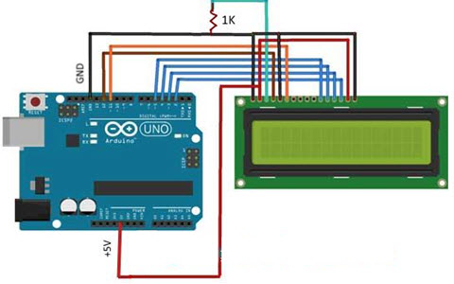

Fig. 2.2

**3.Membrane keypad**: A keypad allows you to interact with a microcontroller. They come in wide variety of shapes and sizes. The most commons sizes are 3×4 and 4×4 and you can get keypads with words, letters and numbers written on the keys.

A membrane keypad is a matrix consisting of rows and columns. Each key is assigned to a certain row and column. On a 12 button keypad you have 4 rows and 3 columns. The first key would make a link between Row 1 and Column 1 (R1C1). 2 would be R1C2, 3 R1C3, *  R4C1, 9 R3C3 and so on.

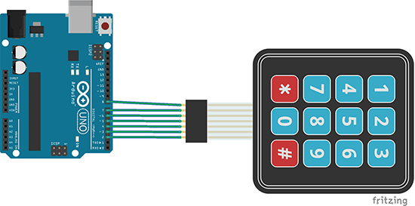

Fig. 2.3

**4.ESP 8266 module**: ESP8266 is an impressive, low cost WiFi module suitable for adding WiFi functionality project. It comes pre-programmed with an AT command set firmware, meaning, you can simply hook this up to your Arduino device and get about as much WiFi-ability as a WiFi Shield offers. This module has a powerful on-board processing and storage capability that allows it to be integrated with the sensors and other application through its GPIOs . Pin description is given below:

The module can work both as a Access point (can create hotspot) and as a station (can connect to Wi-Fi), hence it can easily fetch data and upload it to the internet making Internet of Things as easy as possible. It can also fetch data from internet using API’s hence your project could access any information that is available in the internet, thus making it smarter. Another exciting feature of this module is that it can be programmed using the Arduino IDE which makes it a lot more user friendly.

|  |  |  |
| --- | --- | --- |
| 1 | Ground | Connected to the ground of the circuit |
| 2 | TX | Connected to Rx pin of programmer  to upload program |
| 3 | GPIO-2 | General purpose Input/output pin |
| 4 | CH_EN | Chip Enable – Active high |
| 5 | GPIO - 0 | General purpose Input/output pin |
| 6 | Reset | Resets the module |
| 7 | RX | General purpose Input/output pin |
| 8 | VCC | Connect to +3.3V only |

Table 2.1

Table 2.1 represents the connection of ESP 8266 with arduino.

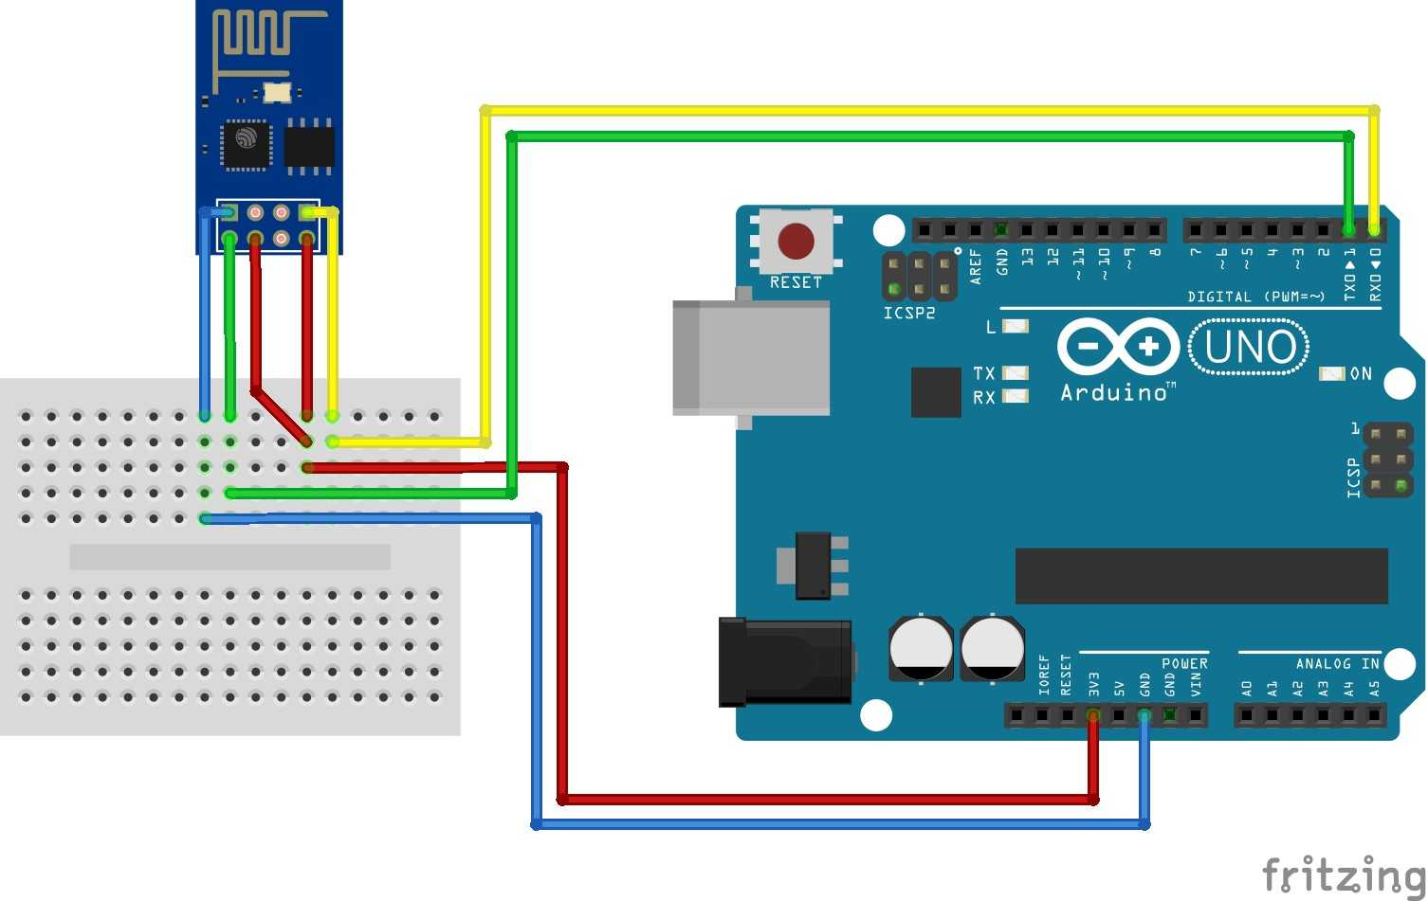

Fig. 2.4

**CHAPTER 3 MODULES OF THE PROJECT**

**Module 1:**

In module 1 we will upload the program to arduino uno board. In this we will calculate the votes of candidate and see if the total number of votes is equal to the total voters and if all voters cast their vote then voting will be over. In this we also check if there is a tie then it will be displayed on lcd screen.

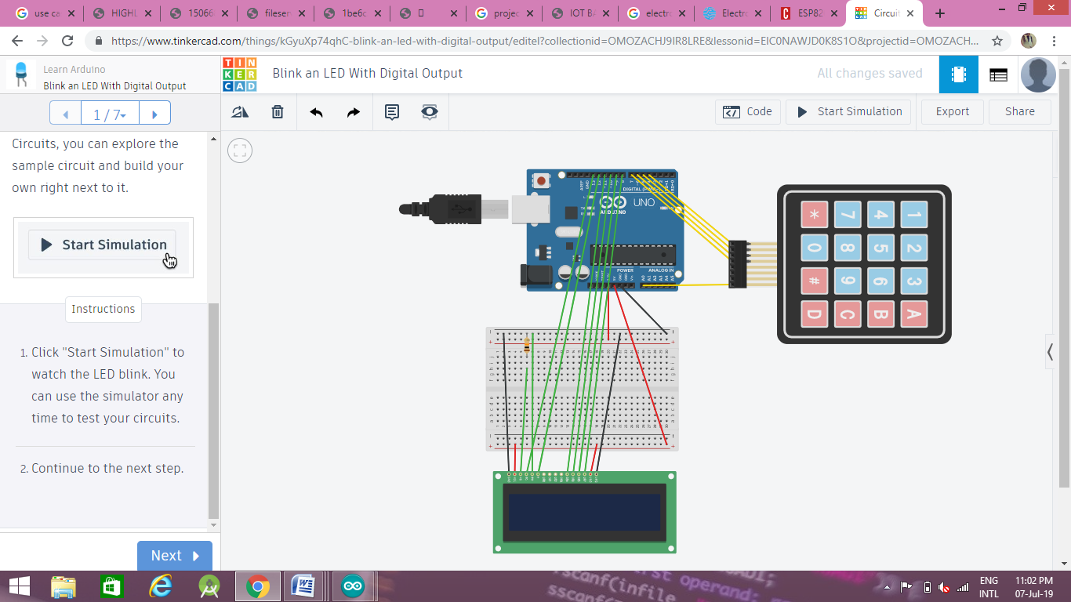

Fig. 3.1

The connection of membrane keypad to Arduino board will be as follows:

|  |  |
| --- | --- |
| **Membrane keypad pin** | **Arduino uno board** |
| Row 1 | Digital pin 4 |
| Row 2 | Digital pin 5 |
| Row 3 | Digital pin 6 |
| Row 4 | Digital pin 7 |
| Col 3 | Analog pin A1 |
| Col 4 | Analog pin A0 |

Here we use only column 4 pin as last column is used.

Table 3.2 represent the connection of LCD screen to Arduino board:

Table 3.2

|  |  |
| --- | --- |
| **LCD pin** | **Arduino uno board** |
| Ground | GND |
| VCC | +5V |
| Contrast pin | GND (Through a register) |
| Register select | Digital pin 13 |
| R/W | GND |
| EN | Digital pin 12 |
| D4 | Digital pin 11 |
| D5 | Digital pin 10 |
| D6 | Digital pin 9 |
| D7 | Digital pin 8 |
| BK VCC | +5V |
| BK GND | GND |

Following buttons are used to:

* 1. A Cast vote to party A
  2. B Cast vote to party B
  3. C Cast vote to party C
  4. D Reset Machine
  5. # Show Result

This module will work as simple EVM machine in which voter can cast his/her vote and it will be added to the respective candidate and display it on the screen. When all the voters cast their vote then result will be displayed on the screen.

In this module we also uploaded code to make a serial communication between arduino uno board and esp8266. So that when voter will send data from browser it will first receive by esp8266 and then transmit data to arduino board through this serial connection. Now board will read data and add the vote to the respective candidate and display on screen.

**Module 2:**

In this module we will upload the program to esp8266 and see how it will receive data and transmit to arduino board.

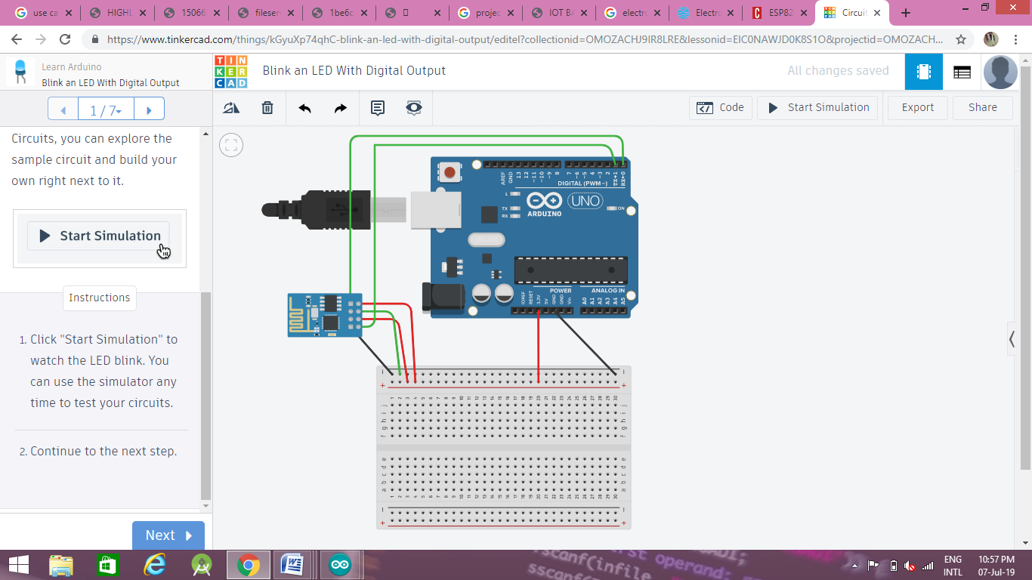

Fig. 3.2

Connections are in Table 3.3:

Table 3.3

|  |  |
| --- | --- |
| **ESP 8266 pin** | **Arduino uno board** |
| Ground | GND |
| VCC | +3.3V |
| RX | Digital pin 0 |
| TX | Digital pin 1 |
| GPIO0 | GND |
| CH_EN | +3.3V |

Firstly we will upload a simple program to display IP address in the serial monitor. Then this IP address is used as a website to open in browser and display the webpage.

IP Address:-192.168.43.55

After this we will upload the main code to esp8266 in which we write html code of different web pages i.e. login page, wrong input page and vote casting page. All these pages are linked together and when voter will cast his/her vote then we will send data to serial monitor which will received by module 1.

In this we will mention the password and SSID of router from which it will connect to internet. Here we also check if login details match the details in the database.

**CHAPTER 4 IMPLEMENTATION DETAILS**

Now both module are ready and we will merge these module and finally implement it to make our final project.

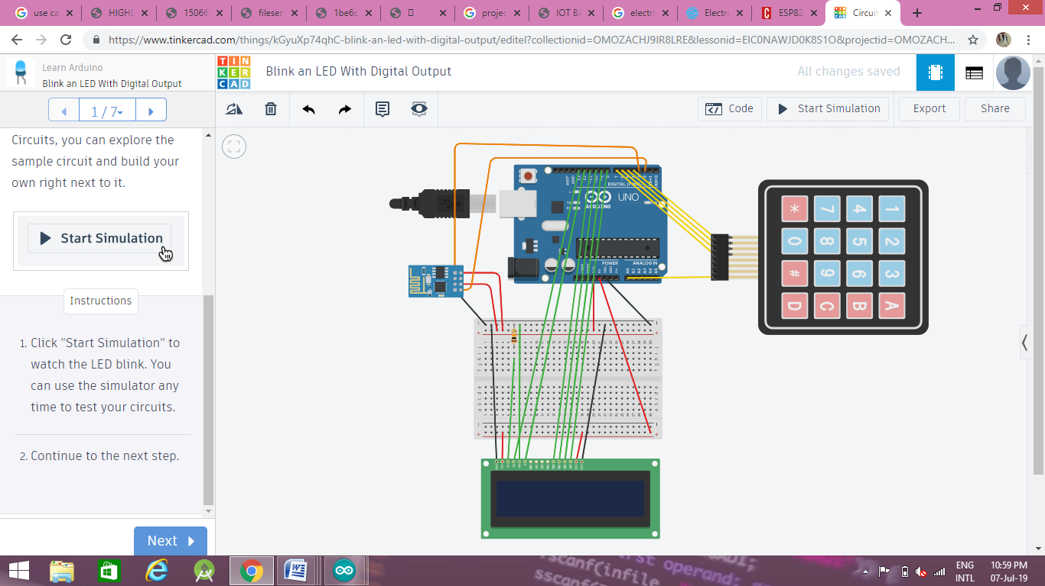

Fig. 4.1

All connections will be same except ESP8266 TX & RX pins.

TX Digital pin 2

RX Digital pin 3

Now our final project is ready. So when we placed it in pooling place and turn on the router. Wifi module will connect to internet through router. Then we should now open up our router settings. Open up our browser and type in the address for router. There we will find some settings, including something along the lines of Forwarding or port forwarding.

The important thing to note here is the "Service port" and the "IP address".

In "Service port", we will type the port that we specified in our Arduino code. (Here it was 80)

In "IP Address", we should type:- IP: ServicePort

After this ESP8266 can be accessed from anywhere. Now the database will be maintained by admin and will provide user id and password to each voter. Admin is also responsible for add/delete/modify parties.

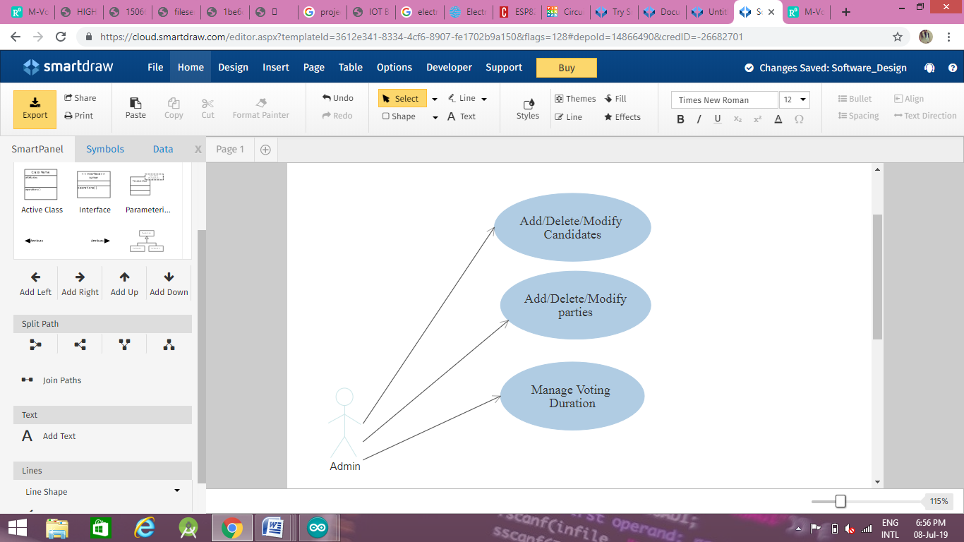

Fig. 4.2 Use case diagram for Admin

Now this password will be provided by government to voters through message to their respective mobile.

On the day of voting, voters can either vote through online or at pooling place. If voter vote his/her vote online then he/she cannot be login again. And if he/she tries to vote both online and offline then voting officer will first check the status of voter in database if he/she hasn't already voted, only after checking he/she will be allowed to vote offline.

If voter vote his/her vote offline then after entering voting station and checking his/her identity by voting officer he/she will be allowed to voting.

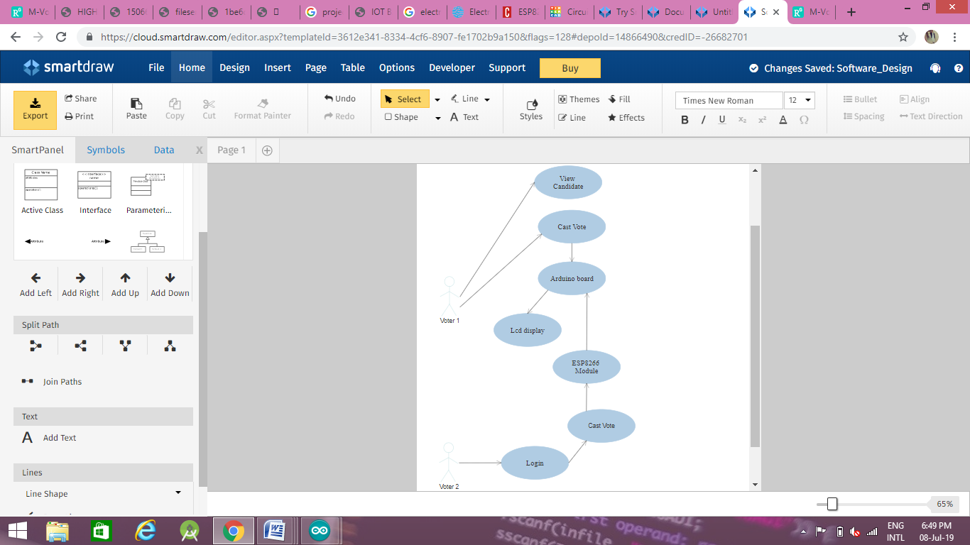

Fig. 4.3 Use case diagram for VoterAfter voting is finished when all the candidates casted their vote then Election authority will view result and generate a report of the election. Election authority hold the responsibility of publish result.

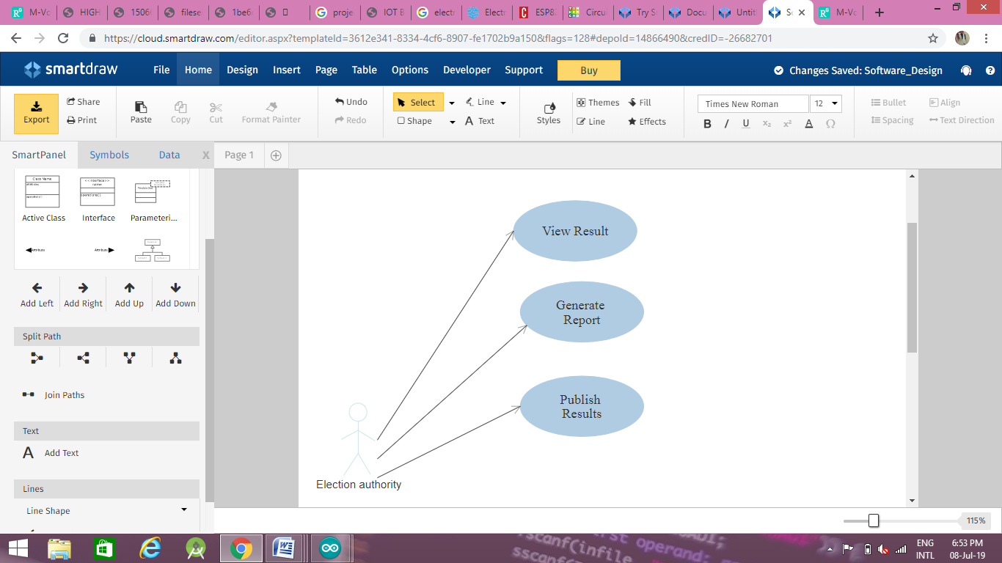

Fig. 4.4 Use case diagram for Election authority

**CHAPTER 5 SCREEN SHOTS**

When we enter the ip address in browser then following web page will display(Fig 5.1):

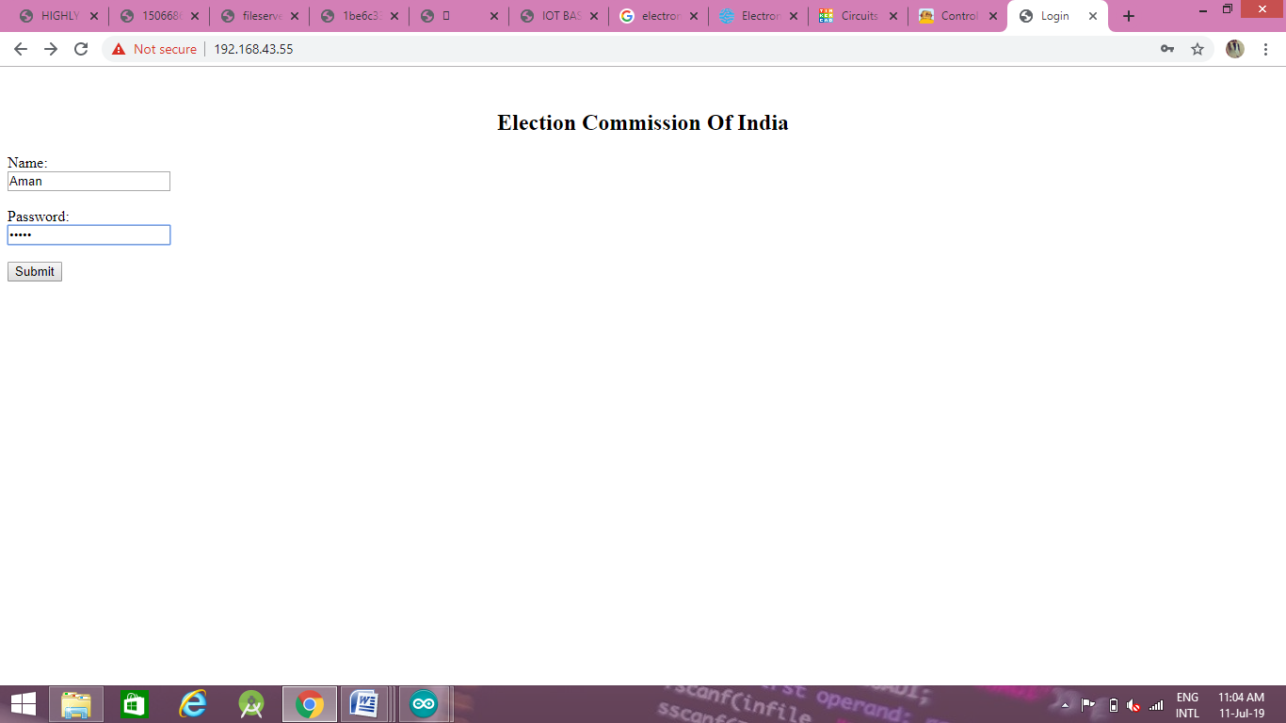

Fig. 5.1

Now if we login through wrong input then it redirect to Fig 5.2:

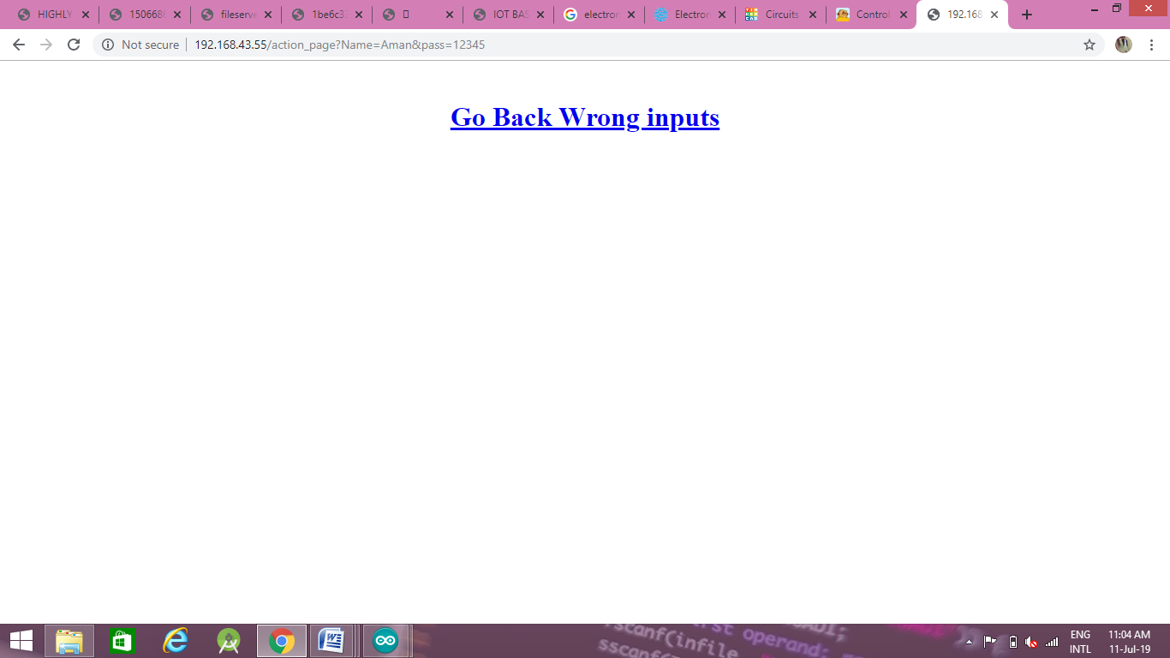

Fig. 5.2

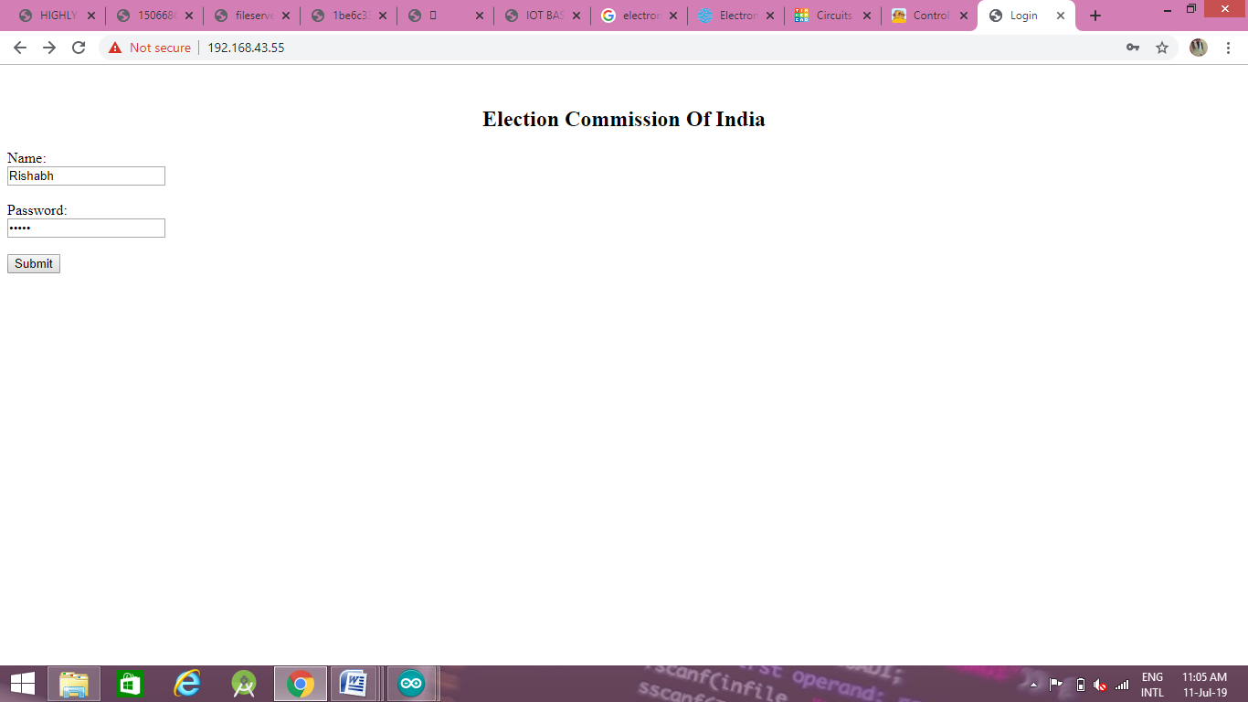

Fig. 5.3

Now if we login through right credentials then following web page will open:

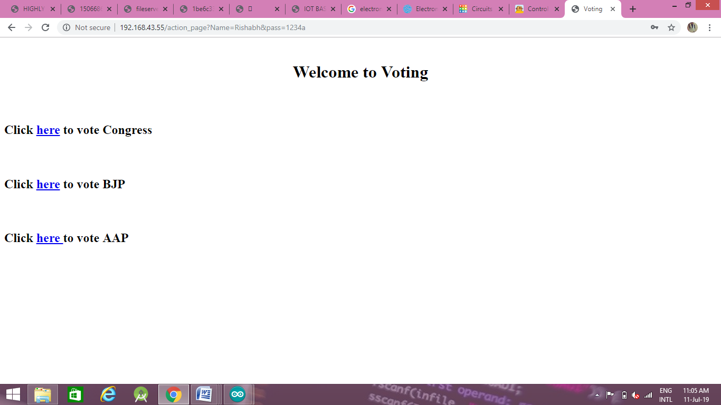

Fig. 5.4

Now we can vote by clicking on the desired candidate.

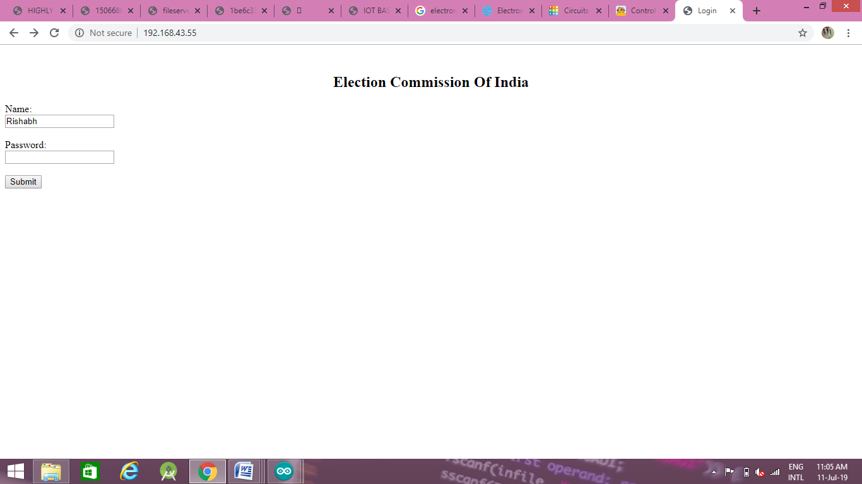 Fig. 5.5

Now after voting it will redirect it to login page and user will not be able to login again.

**CHAPTER 6 CONCLUSION**

This project enable's a voter to give his/her vote over the internet and avoid proxy vote or double voting and quick to access and easy to maintain all information of voting. It reduce or remove unwanted human error. In addition this voting system is capable to handle multiple modules in various centers and provide better scalability for large election.

Cost is less, because human interventions are less in the system. Due to real time approach counting of votes could be done at the same time while voting. The overall system installation is effortless.

**CHAPTER 7 FUTURE SCOPE**

* Unique Identification Numbers (Aadhar cards) have already been introduced in India, for getting more details we can use aadhar card number for login in future.
* To make it user friendly the audio output can be used for illiterate voters.
* Timer can be implemented so that voting will be finished automatically.
* To make it more secure, fingerprint scanner can be used.
* External memory can be provided for storing the finger print image, which can be later accessed for comparison.
* In future, making the voting system online this advanced system will be referred.

**BIBLIOGRAPHY**

1. M. Santhosh, S. Kavitha, R. Keerthana, L. Suganya, and S. Krishnakumar. "Electronic voting machine using internet." *InternationalCommunication and computer Technologies*(2016).
2. Shubham J. Devgirikar, Shailesh A. Deshmukh, Vaibhav P. Paithankar, N. B. Bhawarkar. "Advanced Electronic Voting Machine using Internet of Things (IOT)".(2017)
3. Nithya , Ashwin, Karthikeyan , Ajith kumar. " Advanced Secure Voting System with IoT ". (2016)
4. Swati Gawhale, Vishal Mulik , Pooja Patil, Nilisha Raut. " IOT Based E-Voting System ". International Journal for Research in Applied Science & Engineering Technology (2017) **ABBREVIATIONS**
5. IOT-Internet Of Things
6. EVM-Electronic Voting Machine
7. LCD-Liquid Crystal Display
8. API-Application Program Interface
9. IDE-Integrated Development Environment
10. IP-Internet Protocol
11. SSID-Service Set Identifier